**Quantitative Genetic Modelling of Insecticide Resistance Management: Comparing Sequences and Rotations**

Aims & Objectives:

Aim: To compare the efficacy of sequence and rotation IRM strategies in a quantitative genetics model.

Objectives:

1. To compare the duration of sequence and rotation IRM strategies
2. To compare the parameter space using partial rank correlation.

Methods [Include Additional Model Description in the MRes report; model is fundamentally the same besides being able run with the Sequences/Rotations and Thresholds]:

**Simulation Description**

The model currently allows for a number of user defined inputs that could be under direct operational control. These include the total number of insecticides available, the deployment frequency (how frequently are changes to the insecticide deployment considered). The model tracks the mean insecticide resistance intensity of the population to an insecticide In both the treatment site and the refugia. The treatment site has the insecticide, the refugia is insecticide free. Only a single insecticide is able to be deployed at any one time. The survival thresholds for withdrawal and return can also be user defined inputs. In the current set of simulations the withdrawal threshold is set at 10% bioassay survival and the return threshold is set at 5% bioassay survival. A withdrawn insecticide cannot be reused until the bioassay survival reaches 5%. The bioassay survival for withdrawal and return of insecticides is calculated from the resistance intensity in the treatment site only. Sequences involve a single insecticide being deployed continuously until the resistance intensity meets the withdrawal threshold, where the next insecticide at the next opportunity for deployment. For example insecticide 1 will be deployed continuously until the 10% survival threshold, at which point insecticide 2 will be deployed at the next opportunity for deployment. In the rotation strategy, the insecticide deployed is changed at each deployment interval. In all simulations, insecticide 1 is the first insecticide deployed.

**Model Assumptions**

Each mosquito generation is considered as a discrete unit that only breeds amongst itself, and this mating is random. The population size is assumed to be sufficiently large to prevent inbreeding bottlenecks. There is no cross resistance and cross selection between insecticides, resistance to one insecticide does not provide resistance to another insecticide. All insecticides are novel active ingredients, and as such at all insecticides have an insecticide resistance intensity of 0 at the start. Each insecticide has equivalent insecticidal ability.

**Parameter Space Testing**

The parameter space was tested with 2000 random combinations of input parameter values (insecticide resistance heritability, male insecticide exposure, female insecticide exposure, resistance cost, intervention coverage, dispersal) taken from uniform distributions (Table 1) generated from a Latin hypercube sample. These same 2000 combinations were run using 2, 3 or 4 insecticides, with deployment decisions made at 5, 10 or 20 mosquito generations (approximately 6, 12 and 24 months), with either the sequence or rotation strategy. Therefore a total of 36,000 simulations were conducted.

Each simulation was allowed to run for a maximum of 500 generations (~50 years). If there are no insecticides available for deployment (all insecticides are withdrawn from the armoury), then the model stops as the insecticide arsenal has reached its useable lifespan. The primary outcome from each simulation was the duration (in generations) of the simulation, up to the maximum run time of 500 generations. Three secondary outcomes were also calculated from the simulations. First, the number of generations where an insecticide was in deployment at a resistance intensity exceeding the threshold for withdrawal. Second, the peak insecticide resistance intensity reached in the simulation. Third, the mean insecticide resistance intensity of the deployed insecticide.

During analysis it should be noted that when comparing the secondary outcomes; there may be an issue as not all comparisons will be conducted on simulations of the same duration. This will be especially the case when comparing the number of exceedance generations which would generally expected to increase with an increased number of generations. Therefore comparisons were only made for these secondary outcomes where the simulation ran for the full 500 generations for both the sequence and rotation strategies, or the duration of the simulation was identical for the sequence and rotation pairs.

Additionally, when comparing the simulation duration times between the different deployment frequencies, while it may seem logical that the shorter the time between switching the insecticides the better the strategy, when strategies run out of insecticides during a deployment, this favours having a longer deployment time, as it allows the duration to be extended.

|  |  |  |
| --- | --- | --- |
| **Table 1: Descriptions of Model Inputs** | | |
| **Parameter**  **Name** | **Description of Parameter** | **Value(s)** |
| Insecticide Resistance Intensity | The mean insecticide resistance intensity in the population | Internally calculated |
| Selection differential | The difference in mean insecticide resistance intensity between the value in the population and the parents of the next generation | Internally calculated |
| Selection Response | The increase in insecticide resistance intensity due to insecticide selection pressure in the treatment site (per generation) | Internally calculated |
| Heritability | The heritability of the insecticide resistance intensity value. | Uniform:  0.05 to 0.3 |
| Resistance Cost | The decrease in insecticide resistance intensity due to natural selection when the insecticide is not deployed (per generation); expressed as a proportion of response. | Uniform:  0.01 to 0.2 |
| M-M* parameter | The insecticide resistance intensity value survival in the bioassay is 50%. | 900 (Calculated for the intensity scale). |
| Slope of the Michaelis-Menten | The slope in the Michaelis-Menten equation | 1 |
| 50% Bioassay Survival Resistance | The maximum proportion of mosquitoes that can survive in the bioassay. | 1 |
| Female insecticide exposure | The proportion of female mosquitoes exposed to the insecticide in the treatment site. | Uniform: 0.4 to 0.9 |
| Male insecticide exposure | The proportion of male mosquitoes exposed to insecticide in the treatment site as proportion of the exposure to female mosquitoes. | Uniform: 0-1 |
| Exposure scaling factor | A factor that converts insecticide exposure into insecticide selection differential. | Empirically calculated as 10. |
| Intervention Coverage | Proportion of the mosquito population in the insecticide treated site. | Uniform: 0.1 to 0.9 |
| Dispersal | Proportion of the mosquito population exchanged between the insecticide treated site and the insecticide free refugia per generation. | Uniform: 0.1 to 0.9 |
| IRM Strategy | The type of IRM strategy deployed. | Sequence or Rotation |
| Withdrawal Threshold | The bioassay survival proportion that leads to the withdrawal of the insecticide from the insecticide armoury. | 0.1 |
| Return Threshold | The bioassay survival proportion that leads to the return of the insecticide back to the insecticide armoury. | 0.05 |

**Statistical Analysis**

Mean and 95% confidence intervals were calculated for the Rotation and Sequence simulations grouped by the deployment frequency and number of insecticides, giving a total of 9 comparisons between the Rotation and Sequence strategy on the secondary outcomes of peak resistance intensity, mean resistance intensity to the deployed insecticide and number of exceedance generations.

Partial rank correlation was conducted on all simulations, grouped by IRM strategy, including the explanatory variables: insecticide resistance heritability; resistance cost; male insecticide exposure; intervention coverage; mosquito dispersal and female insecticide exposure.

A Generalised Linear Model (GLM) was conducted assuming a negative binomial distribution (Testing for overdispersion on the Poisson GLM gave dispersion = 5.63322, z = 47.014, p-value < 2.2e-16). All explanatory variables were included in the intial GLM. The number of insecticides, IRM strategy and frequency of deployment were included as factors. Stepwise AIC elimination was then conducted on the model.

**Results**:

A total of 36,000 individual simulations (Figure 1) were conducted, comprising of 18,000 sequence simulations paired to 18,000 rotation simulations. Of the 18000 comparisons between sequences and rotations, rotations were found to have a longer simulation duration time in 2411 (13.29%), the remaining 15589 (86.61%) of comparisons were found to have equal simulation durations. There were no occasions where the duration of the sequence simulation was longer than the duration of the rotation simulation.

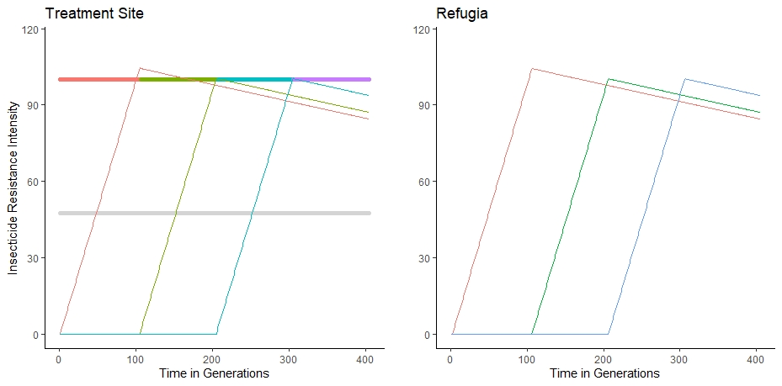

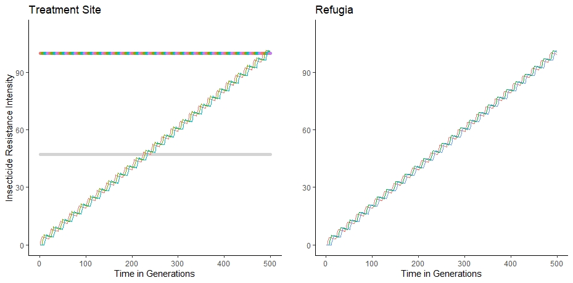

**Figure 1: Example Model Comparison Between the Sequence and Rotation Insecticide Resistance Management Strategies with Identical Random Parameters.** Top Panels: Outputs from the Sequence strategy in the treatment site and refugia. Bottom Panels: Outputs from the Rotation strategy in the treatment site and refugia. A parameter input combination was randomly selected from the Latin hypercube sample. The multicoloured horizontal line indicates the insecticide in deployment and is also the 10% survival withdrawal threshold. The grey horizontal line indicates the 5% survival return threshold.

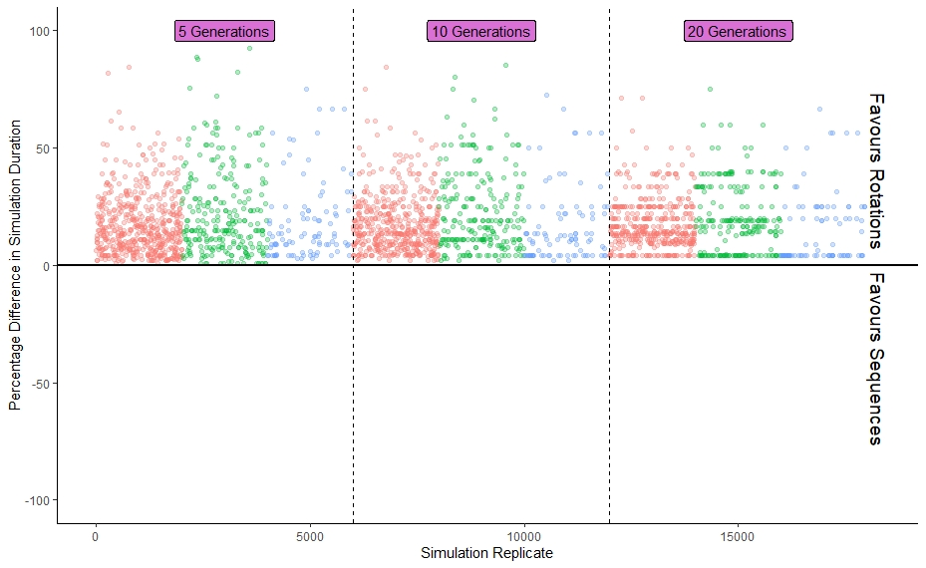**Figure 2: Percentage Difference in the Duration of the Simulations for Sequences and Rotations.** Only includes cases where there was a difference (n=2411 simulation pairs). Colours indicate the number of insecticides included in the simulation: red = 2, green = 3, blue = 4. These are subsequently grouped by the deployment frequency in generations (either 5, 10 or 20 generations).

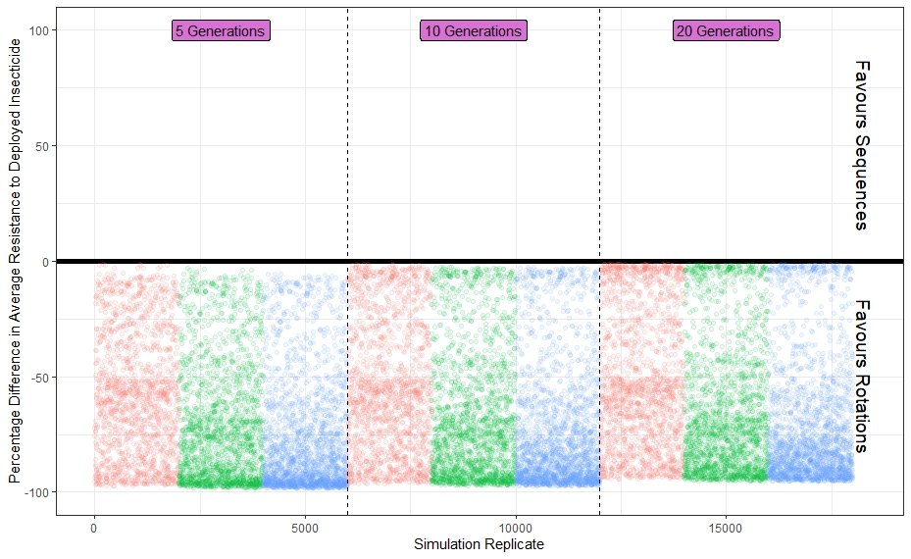**Figure 3: Difference in the Mean Insecticide Resistance Intensity to the Deployed Insecticide in Sequences and Rotations.** Only includes paired simulations where the duration of the simulation was equal (n = 15589 paired simulations). Colours indicate the number of insecticides included in the simulation: red = 2, green = 3, blue = 4. These are subsequently grouped by the deployment frequency in generations (either 5, 10 or 20 generations).

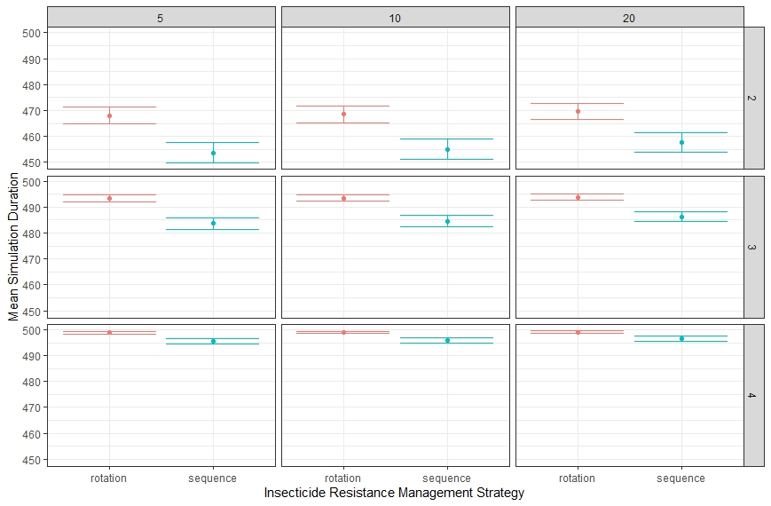**Figure 4: Mean and 95% Confidence Interval of the Duration of Simulations for Sequences and Rotations.** Columns are the deployment frequencies in mosquito generations. Rows are the number of insecticides in the simulation.

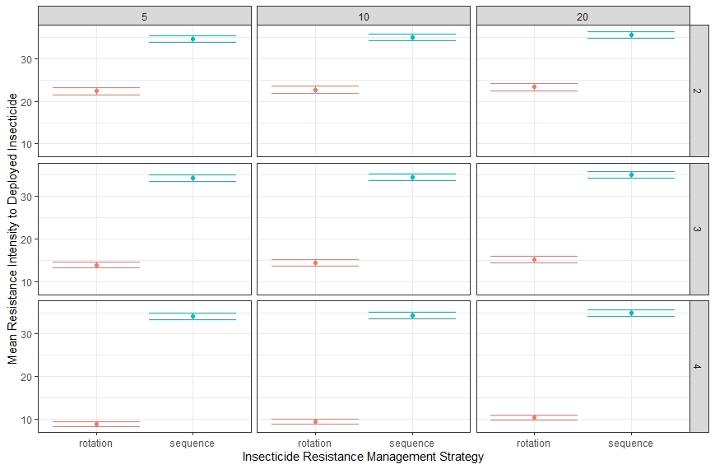**Figure 5: Mean and 95% Confidence Interval for the Mean Resistance Intensity to the Deployed Insecticide.** Columns are the deployment frequencies in mosquito generations. Rows are the number of insecticides in the simulation. Including all paired simulations regardless of differences in simulation duration.

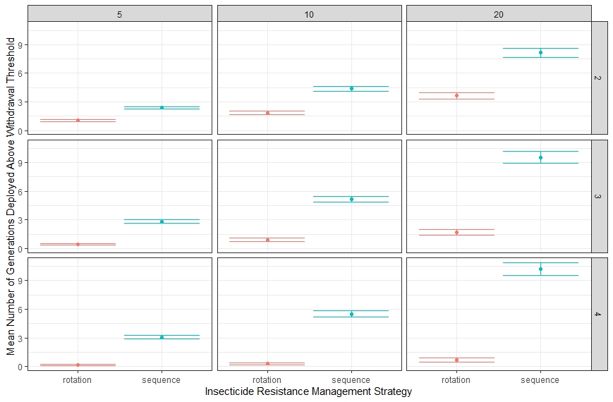**Figure 6: Mean and 95% Confidence Interval of the Number of Generations an Insecticide was Deployed above the Withdrawal Threshold.** Columns are the deployment frequencies in mosquito generations. Rows are the number of insecticides in the simulation. Including all paired simulations regardless of differences in simulation duration.

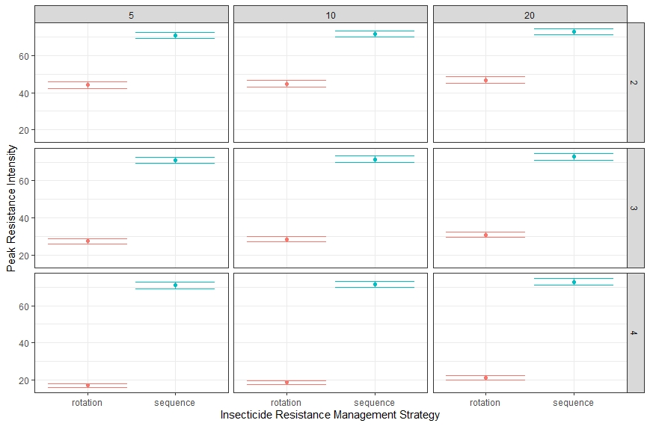**Figure 7: Mean and 95% Confidence Interval of the Peak Insecticide Resistance Intensity.** Columns are the deployment frequencies in mosquito generations. Rows are the number of insecticides in the simulation. Including all paired simulations regardless of differences in simulation duration.

|  |  |  |  |
| --- | --- | --- | --- |
| **Table 2: Partial Rank Correlation on Simulation Duration** | | | |
| **Rotations** | | | |
| **Parameter** | **Estimate** | **P value** | **Test Statistic** |
| Insecticide Resistance Heritability | 0.4732990 | 0.00e+00 | 72.07089 |
| Resistance Cost | -0.4388995 | 0.00e+0 | -65.52112 |
| Male Insecticide Exposure | 0.2200381 | 3.37e-196 | 30.25703 |
| Intervention Coverage | 0.7667708 | 0.0000 | 160.22705 |
| Mosquito Dispersal | -0.2548746 | 8.65e-265 | -35.35602 |
| Female Insecticide Exposure | 0.2410168 | 3.73e-236 | 33.31150 |
| **Sequences** | | | |
| **Parameter** | **Estimate** | **P Value** | **Test Statistic** |
| Insecticide Resistance Heritability | 0.5404393 | 0.00e+00 | 86.15985 |
| Resistance Cost | -0.2927851 | 0.00e+00 | -41.07352 |
| Male Insecticide Exposure | 0.2318240 | 3.78e-218 | 31.96727 |
| Intervention Coverage | 0.8635094 | 0.00e+00 | 229.66868 |
| Mosquito Dispersal | -0.4056980 | 0.00e+00 | -59.53949 |
| Female Insecticide Exposure | 0.3044932 | 0.00e+00 | 42.88030 |

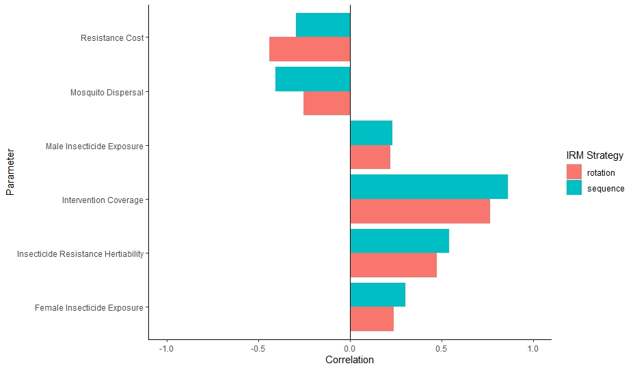**Figure 8: Partial Rank Correlation Coefficients for Sequences and Rotations on the Duration of the Simulation.**

Generalised Linear Model on Simulation Duration (Negative Binomial Distribution)

|  |  |  |  |  |
| --- | --- | --- | --- | --- |
| Table 3: Results of the Negative Binomial Generalised Linear Model on the Simulation Duration | | | | |
| **Parameter** | **Estimate** | **Standard Error** | **Z value** | **P value** |
| Intercept | 6.290615 | 0.004259 | 1476.912 | <2e-16 |
| IRM Strategy: Sequence | -0.018093 | 0.001310 | -13.810 | <2e-16 |
| Deployment Frequency: 10 Generations | 0.001243 | 0.001605 | 0.775 | 0.4385 |
| Deployment Frequency: 20 Generations | 0.003632 | 0.001605 | 2.264 | 0.0236 |
| Male Insecticide Exposure | -0.053655 | 0.002271 | -23.625 | <2e-16 |
| Resistance Cost | 0.231734 | 0.011952 | 19.389 | <2e-16 |
| Dispersal | 0.032394 | 0.002839 | 11.410 | <2e-16 |
| Number of Insecticides: 3 | 0.059121 | 0.001606 | 36.805 | <2e-16 |
| Number of Insecticides: 4 | 0.076896 | 0.001605 | 47.899 | <2e-16 |
| Insecticide Resistance Heritability | -0.441454 | 0.009085 | -48.590 | <2e-16 |
| Female Insecticide Exposure | -0.133138 | 0.004541 | -29.317 | <2e-16 |
| Null deviance: 44139 on 35999 degrees of freedom  Residual deviance: 37464 on 35989 degrees of freedom  AIC: 397944 | | | | |

Generalised linear modelling suggests that the difference in the effect size of the IRM strategy is small, although it does favour the use of rotations over sequences. Counter-intuitively, longer times between each deployment decision appears to increase the longevity of the simulation. However this effect is small, and is therefore more likely due to the model stopping at the end of a deployment, rather than the time point when the insecticide would be withdrawn. For example if the withdrawal threshold for all insecticides is exceeded four generations into a deployment, then when the deployment frequency is every five generations there is only 1 more generation before the model is stopped, whereas if the deployment frequency is 20 generations then would be 16 more generations still to run before the model is stopped. And because the simulation duration is 15 generations longer would appear to be the better strategy.

**Discussion/Interpretation/Future Developments**

**Sequences versus Rotations**

The analysis of the model outputs suggests that rotations are a marginally more optimal IRM strategy than sequences, as highlighted by rotations performing statistically better than sequences. However, the large number of simulations run (36,000) gives a large amount of statistical power to be able to detect very small differences in effect size. This is an important point that needs to be highlighted, while the statistical difference very much favours the use of rotation strategies above sequences, the effect size is so small that it is unlikely that at an operational level with large amounts of biological and logistical variation that this effect would get overwhelmed by the natural noise of the system. This is especially the case when minor fluctuations in the behaviour and ecology of the mosquitoes are likely to have a far bigger impact on the direction and magnitude of selection than the choice of a sequence or rotation IRM strategy.

**Future Model Development:**

The next steps in model development are to look to include the ability to model the impact of cross resistance and cross selection between insecticides, by incorporating through the multivariate breeder’s equation, and to look at the deployment of multiple insecticides (as a mixture (two insecticides encountered simultaneously) and as a combination (in the notion as deploying as two separate interventions for example an ITN and IRS where a single mosquito does not necessarily come into contact with both insecticides).